  
   
Flashing Large Mammals

Torgeir Holmgard Valle

# Introduction

How does the usage of white LED flash affect our data?

Litt om estimeringsmetoder og problemer - og at det er særlig vanskelig for nattaktive og sky arter. Litt om bruk av kamerafeller og metodikk som er i enorm utvikling. Binde opp til NINA arbeid og samarbeid i Skandinavia

Capture Recapture models only available for naturally marked species (e.g. tigers *Panthera tigris*, leopards *Panthera pardus*). “Nevertheless, the majority of wildlife species are not easily individually identifiable from photos, rendering CR approaches difficult and leading to widespread interest in alternate analytical approaches for ‘unmarked’ species”

Camera traps give us the opportunity to monitor in a quantifiable, somewhat standardised way, that is almost non-invasive. Normally the cameras have been using infrared light to flash animals during the night, as this was believed to be invisible to the animals (although - unfortunately for us - it is not). However, the lack of sharpness and detail in these photos limit the information we can retrieve from them (e.g. individual variation in coloration), which has brought us to the usage of white LED flashes. Naturally, the white LED flash is highly visible for any surface dwelling mammal, which begs the question to what extent it impacts the animals. Or rather, to which *additional* extent it impacts the animals, and therefore, how it affects our data. Animal sightings by camera traps can be used to measure species density, and any deviation from the norm in probability of sighting, will skew the precision of the estimate. showed that wolfs (*Canis lupus*) tend to shy away from camera traps using white LED flash, whilst the lynx (*Lynx lynx*) is less bothered, compared to the usage of infrared flashes. The wolfs were more shy and aware of all cameras in general, attributed to their higher sense of smell, which is a reminder that each species will perceive the camera presence different, and thus behave differently as a respone to the stimuli.

###### Ledestjerne

In this study, I will attempt to quantify how the usage of white LED flash affects the detection rate of *the most common large mammal species in the area* and whether this effect correlates with other factors as urbanisation.

* Hypothesis 0: Usage of white LED flash will have no effect on the detection rate of any species.

* Hypothesis 1: Usage of white LED flash will stress one or more species in general, and therefore lower the detection rate of the stressed species. The effect will likely vary in extent between species.

* Hypothesis 2: The effect of the white LED will correlate with urbanisation-factors, as individuals that live closer to urban areas are habituated to Artificial Light At Night (ALAN), and thus will have a weaker response to the white LED

# Method and materials

## Study species

The species I’ll focus on in this thesis are the species that most frequently was observed *(>50 events)*, excluding farmed animals (e.g. cattle), humans and dogs, and grouped categories of animals (e.g. birds). Given that the decisions on camera placement (height and angle) were made with the aim on photo capturing lynx(), I have also excluded smaller species from the analysis. This includes three species, squirrel(), hare() and European pine marten*(Martes martes)*. Though they showed up frequently on many locations, there are inevitably some cameras that are too biased towards larger animals, resulting in an inconsistency of their detection rates. In turn, it is difficult to distinguish whether the species was affected by the white LED or not, as they could have triggered the camera, but already escaped the frame. In the end, the species I have used in my analyses are roe deer*()*, red fox*()*, badger*(Meles meles)*, moose*()*, red deer*(Cervus elaphus)* and lynx.

## Study area

The study area (59.36-60.47° N, 9.43-10.91° E) extends over much of the southeastern parts of Norway in counties Flå, Krødsherad, Sigdal, Ringerike, Modum, Hole, Lier, Øvre Eiker, Asker, Oslo, Enebakk, Indre Østfold, Våler, Råde, Moss, Frogn and Vestby. The climate has a continental character due to rain shadows of the mountain ridges from the west.

The mean annual temperatures ranges from 2-6and precipitation lies between 700-1500mm (). Topography is predominantly flat towards the south, and more rugged and elevated towards the north. The landscape is a mosaic of forest and agricultural areas, divided with a wide network of gravel roads. The area is situated in the southern boreal and the boreonemoral zones. Norway spruce (*Picea abies*) and Scots pine (*Pinus sylvestris*) make up the dominating boreal coniferous forests, with frequent presence of silver birch (*Betula pendula*) and downy birch (*Betula pubescens*), then aspen (*Populous tremula*), alder (*Alnus incana*) and black alder (*Alnus glutinosa*).

Growing season length 170 - 190 days (Moen, 1999, map 6, s.21) Snow cover length Most cameras were set in forest areas, usually by a tractor path or human trail, sometimes by animal paths. Their distance from houses or roads varied to a large extent, and some areas were logged (ved Vansjø) and even greatly changed under development of new infrastructure (toglinje på nordligste kamera  1255)

## Study design

For the study I chose 60 already established camera sites with infrared light(Reconyx and Browning models). The cameras had been installed on trees 1-3 meters from human or tractor paths, 40-120 cm above ground level, with the original aim to photo capture lynx (). I divided the sites randomly into three groups of 20 cameras. Cameras in group A remained unchanged, whilst group B and C were equipped with an additional white LED camera (Reconyx PC850) in alternating 3 month-periods, as shown in figure.

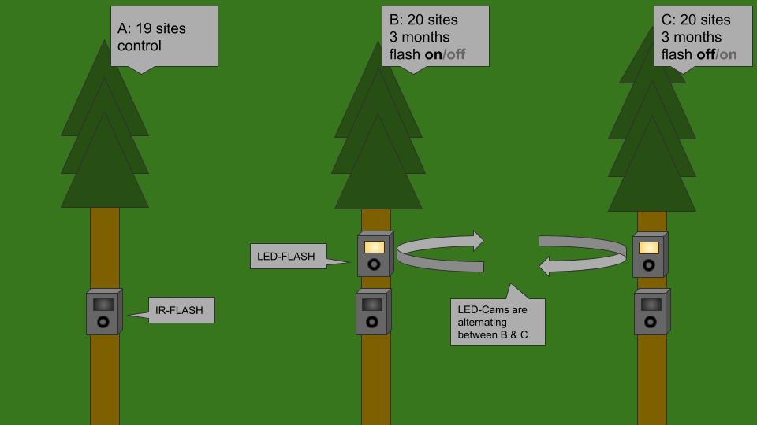

Experiment setup

The preinstalled cameras were set up and handled by people from the Norwegian Institute of Nature Research (NINA) and — at the sites further from Oslo — by members of the Norwegian Hunters and Fishers Society (NJFF). The installation of the cameras did not follow a strict protocol, nor were their locations chosen randomly. The overall placement was systematic as decided by NINA, then there was a deliberately-biased placement of the CTs put up in areas where the individual handler deemed it most likely to photograph lynx, and hence, based on a combination of site accessibility and expectations of animal occurence As shown in figure, I set up all white LED cameras above the cameras already in place. However, at the particular site shown in figure the infrared camera had been installed so far above ground level that I chose to position the white LED camera below the camera already in place. For the periods without white flash treatment, I moved the cameras to their next site. However, the boxes installed on the trees remained (see figure [fig:cam_ex_d]). First, I equipped Group B with an additional white LED as seen in . After approximately three months, I moved the white LED cameras to group C. These two periods were both marked as period 1-1, as seen in . The camera boxes remained at each site untill the end of the experiment. Note that group C had no extra boxes before the start of their first period in May 2019 (i.e. remained identical to the control group A untill May).

[fig:period_timeseries]

I visited sites of group B and C at least once every three months in order to move the LED cameras. For convenience I visited sites of group A less often. However, as the cameras were part of other, ongoing projects, they were occasionally visited by other workers from NINA to retreive the Secure Digital memory cards (hereby SD Cards) for data. This was mostly the case for sites close to, and south of, Oslo, or rather, the cameras not normally operated by members of the NJFF.

.5 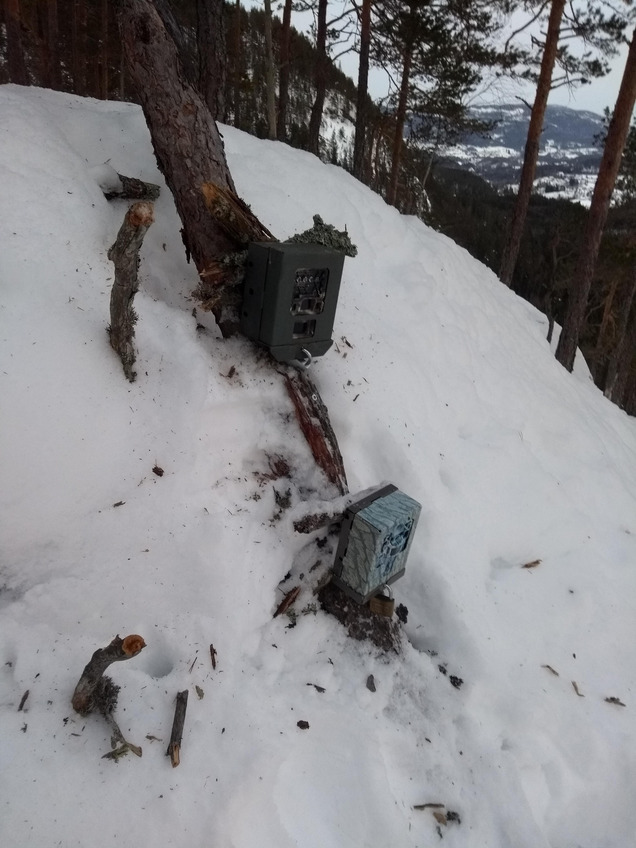

.5 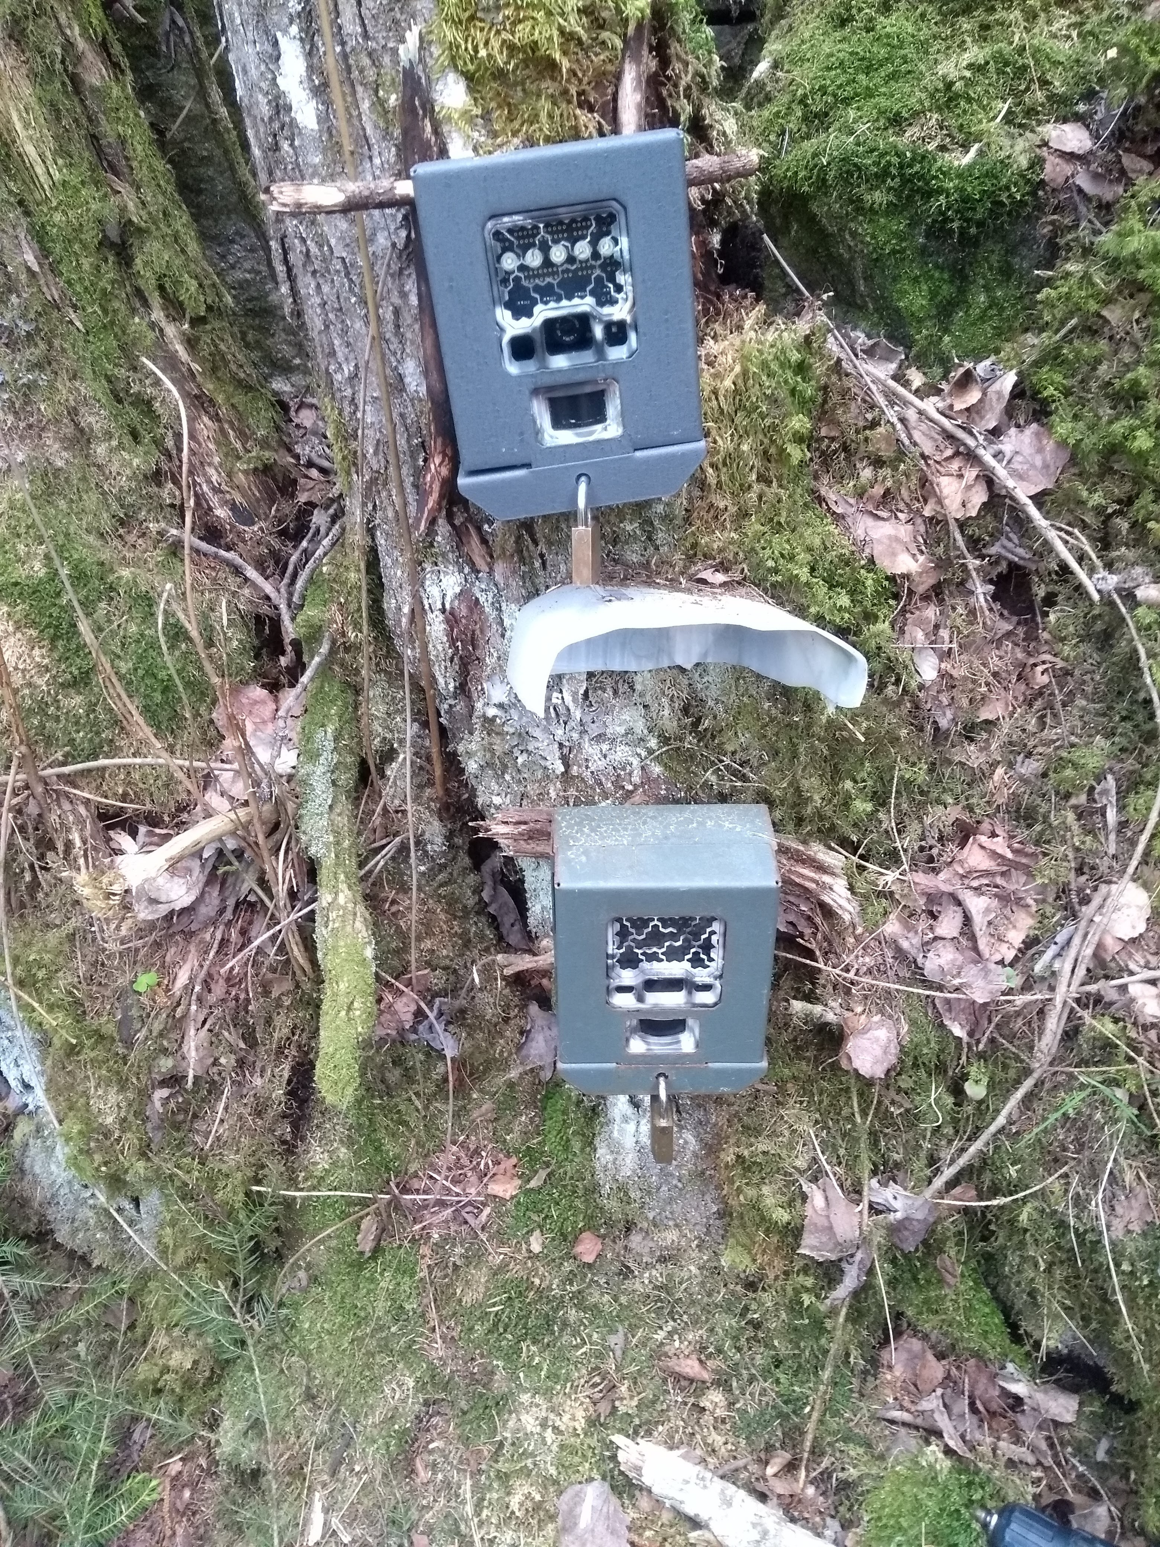

.5 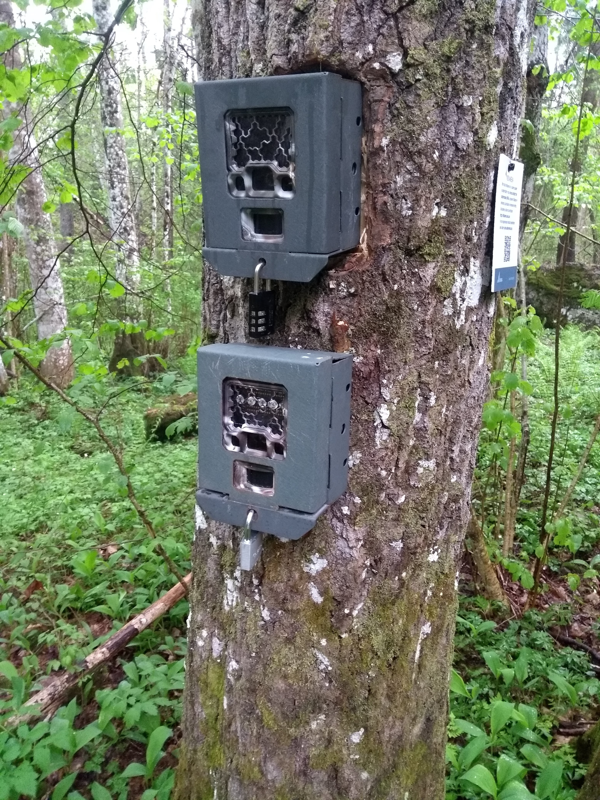

.5 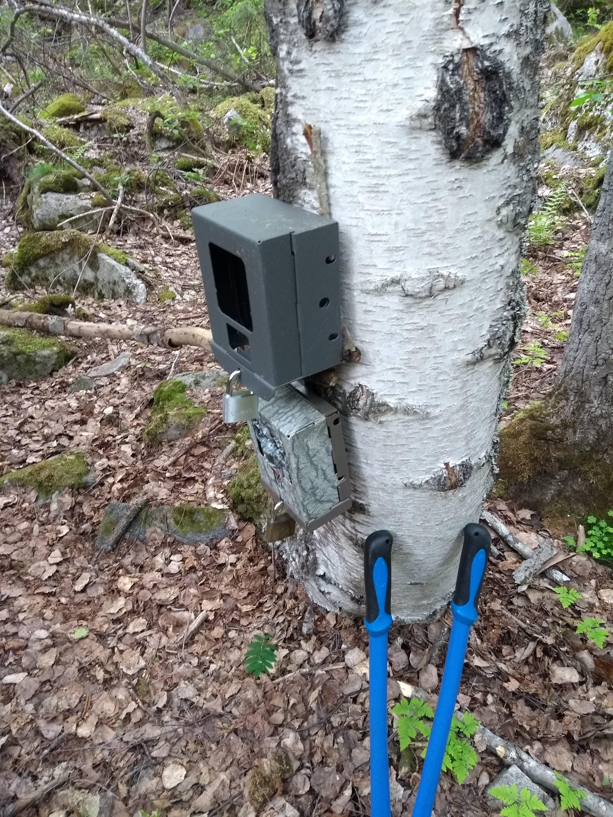

## Data Collection

Five different models of RECONYX™ (address: 3828 Creekside Ln, Ste 2, Holmen, WI 54636, USA, www.reconyx.com) cameras were used, and one model of BROWNING™ (address: One Browning Place, Morgan, UT 84050, USA, www.browningtrailcameras.com), details in table [tab:cam_mod].

Reconyx-cameras have been reported of having an average trigger speed of 0.2 seconds, whereas the Browning model was reported an average of 0.7 seconds (Trigger speed shootout, ).

[tab:cam_mod] Camera models

|  |  |  |  |  |  |
| --- | --- | --- | --- | --- | --- |
| Producent | Model name | Flash type | Trigger speed | photos/trigger | N |
|  | HC500 Semi-Covert IR | IR | 0.2s | 3 | ? |
|  | HC600 High-Output Covert IR | Black | 0.2s | 3 | ? |
|  | PC800 Profoessional Semi-Covert IR | IR | 0.2s | 3 | ? |
|  | PC900 Professional Covert IR | Black | 0.2s | 3 | ? |
|  | PC850 Professional White Flash LED | White | 0.2s | 8 | 20 |
| Browning | Spec Ops: Extreme | IR | 0.7s | 24 |  |

Cameras were operating 24 hours per day. The RECONYX™ cameras were set to take one time lapse photo per day in order to verify that the cameras had been operational. They were set to take 3 pictures per series, as fast as possible using *rapidfire*, and retrigger immediately using *no delay*.

The BROWNING™ cameras were also set to rapidfire, but to 8 photos per trigger, which unfortunately made the memory cards more vulnerable to filling up before being collected. This happened in some areas with sheep and/or cattle, and sometimes due to triggering by vegetation.

Therefore, the BROWNING™ cameras tended to have more gaps of inoperable days. As seen in figure [fig:map], there was a correlation between latitude and camera type. In addition, there were a correlation between camera type and which trail type the cameras were put up in. BROWNING™ cameras were more frequently set up in trail types easily accessible by man, which in turn lead to more pictures of humans and vehicles on the browning cameras.

These differences should all be kept in mind when interpreting the models.

Whenever I noticed vegetation blocking the view of the camera, or excessively triggering it, I removed the vegetation.

[fig:map]

## Data processing

All SD cards were delivered to NINA for data collection. Firstly, a facial recognition algorithm (FRA) is used to sort all the pictures. Afterwards, a human sorter checks the softwares’ output, confirming all the correct decisions (i.e. species detections) and correcting all the wrong ones. The goal is to fully automate this process, which is a request from The Norwegian Data Protection Authority (DPA) in relation to usage of cameras in densely crowded areas (e.g. parks). As per the four eyes principle, the detection rate of photographed species has gone up as a result of the FRA (pers.comm. John Odden).

The output I got as a result, was a data frame containing a time stamp for every shutter activity, including all meta data from the camera, coupled with predicted species (FRA output, with a confidence number), verified species (by human sorters), number of animals and distance from camera. The time stamps from the white flash cameras were used to verify whether an animal was in fact flashed or not, which I then used as my main predictor in the modelling.

I defined one event as any 1 species passing with a buffer time of 5 min before or after

The true number of active camera days are confounded by the inconvenient lack of time lapse photos from the Browning cameras. To approach the true number of active days, I assumed all Browning cameras to be functional every day, unless the camera was inactive when I visited it. In that case, I considered the camera inactive since the day of its last photo.

## Statistical analysis

To test for effects of the white LED flash I used the R programming language (), in the RStudio IDE (), adopting large parts of the tidyverse framework along the way (). Session info in appendix [app:sessinfo].

### GLMM

To test $H_{1}$ I looked for differences in detection rate per day, using Generalised Linear Mixed Models (GLMM) with the R package lme4 ().

My dependant variable was count data, which follows a Poisson distribution ($X∼Pois(λ)$). That is, any value is a non-negative real number (0, 1, 2, ..., k), and randomly distributed. Thus, the error follows a non-Gaussian distribution, which calls for *generalised* linear models.

My *fixed effects*, or predictors, were flash type (white LED present/absent or control group), and time since deployment in days. For the cameras that was equipped with an additional white LED camera, time since deployment starts from the day I visited the camera, and set up/ took down the white LED. The control group’s “day 0” of the time since deployment was set at arbitrary points by me when doing the analysis, in order to obtain periods of similar lengths to that of the experiment-locations. See period breaks in [fig:period_timeseries]. Further, I also trimmed the period lengths down to a maximum length, based on the median length of the IR and white LED periods. Thus, any period exceeding the shortest median length, was trimmed down, as visualised in [fig:median_period]. As I expected there to be a trend over time, I included an interaction term between the fixed effects.

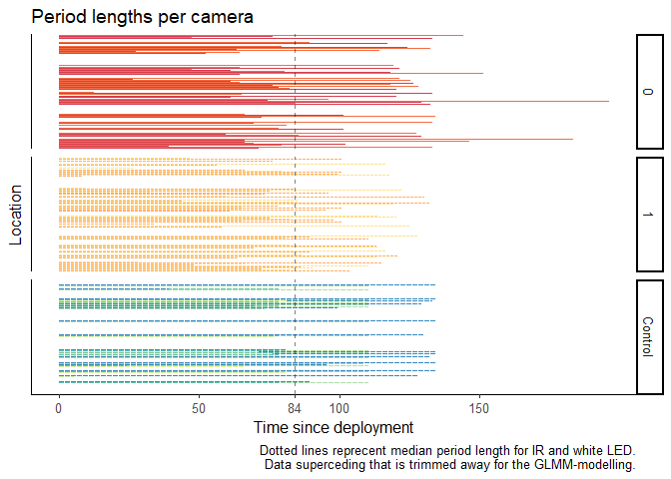

[fig:median_period] Period lengths

1 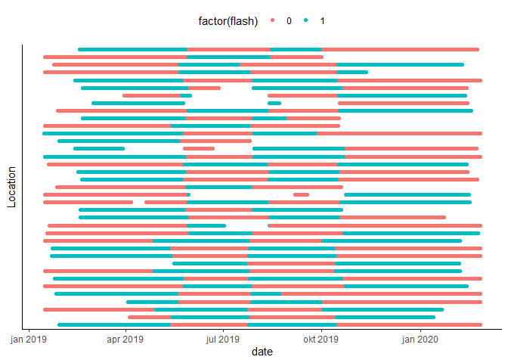

1 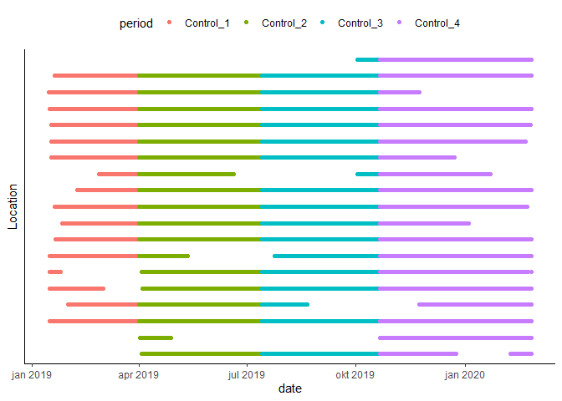

As previously mentioned, there were large differences in height, angle and microhabitat/ trail type between the cameras. Further, the different periods were spread out across the year, leading to seasonal changes in the dataset that weren’t syncronised along the time since deployment-axis for each period. To account for these differences I included random effects in my model for location ID and week of the year. A mixed effect model was required to include both fixed and random effects.

In sum, I needed a *generalised* linear *mixed* model (**GLMM**), which I fit to a subset of each species using the function glmer from the R package lme4 ().

In full, the formula was:

$$n.obs∼time×flash+(1|loc)+(1|week)$$

However, this model only takes into account whether a flash was present or not. It can’t tell if the flash actually went off, or how many times it did.

### Cox Proportional Hazards

Therefore I set up a new column in my dataset called flashed, that told if the flash went off in syncrony with the IR camera. I then used the flashed-column to set up a time to event-analysis.

Also called Survival analysis, time to event-analyses compares groups’ risk of experiencing an event, and was first developed for use in medicinal studies (e.g. cancer risk studies).

The difference between the groups is called the hazard *ratio*, and is *assumed to be proportional* over time. That is, if after 2 days, the hazard of detecting a fox (i.e. experiencing an event) for the IR-group is twice as large compared to the white LED-group, it should remain twice as large after 25 days as well. Or in other words, the IR-group should detect twice as many foxes as the white LED-group in general.

The Cox proportional hazards regression model (CPH model) (Cox, 1972), is a popular development of the time to event-analysis because it allows for more than one predictor. I used the R package Survival () and the function coxme from the R package coxme to perform a CPH with mixed effects (fixed and random effects).

Again, location ID and week of the year were used as random effects to account for differences between the camera sites and seasonal changes during the study period.

As fixed effect I used the flashed-column. If a species was flashed, it went into the “flashed”-group, and time to next detection was recorded. If the species didn’t reappear it was “censored” from the model.

In survival-analyses the time-variable is part of the outcome of the model. Event (i.e. detection) and time is joined as a Surv-object by the Surv function from the Survival package.

Both these models told me something about the fallacy of $H_{0}$, whether I could reject it, or fail to reject it. If the null hypothesis was rejected for a species, I considered $H_{1}$ to be true. Then I went on to test $H_{2}$

### Spatial covariates

To test $H_{2}$, I performed a new CPH, and looked for an interaction between the flashed-variable, and a spatial covariate for distance to nearest house as a proxy for urbanisation and ALAN (data from FKB). This time, I removed the random effect of Location ID in order to include the spatial variation in my data. This complicate things as I now reinclude latitude-correlation with IR camera models, different angles etc.

Kommentar: stopper her inntil videre. Det er truleg for liten tid til å gjennomføre denne analysen, i tillegg til at den kanskje er vanskelig å tolke / lite truverdig når eg ikkje kan kontrollere for forskjeller mellom kamera lenger.

### P-tests and assumptions

For both the GLMM and the CPH mixed effect model, I used the Wald test as significance test, with xyz distribution over df degrees of freedom. osvosv.

The R package performance (cite) was used to check assumptions for GLMM, and ggeffects (cite) was used to visualize the results.

R package Survminer was used to visualize the results of the time to event analyses. The Schoenfeld test was used to check for the CPH’s assumption of proportional hazards.

## Results

### GLMM

Results of the roe deer.

Model formula: n.obs   time.deploy + flash + (1|loc) + (1|week)

I fitted a poisson mixed model (estimated using ML and Nelder-Mead optimizer) to predict n.obs with time.deploy and flash (formula: n.obs   time.deploy * flash). The model included loc and week as random effects (formula: list( 1 | loc,  1 | week)). The model’s total explanatory power is substantial (conditional R2 = 0.45) and the part related to the fixed effects alone (marginal R2) is of 1.95e-03. The model’s intercept, corresponding to time.deploy = 0 and flash = 0, is at -3.38 (95% CI [-3.97, -2.78], p < .001).

Standardized parameters were obtained by fitting the model on a standardized version of the dataset. 95% Confidence Intervals (CIs) and p-values were computed using the Wald approximation. Predicted counts visualised in , model parameters visualised in .

.5 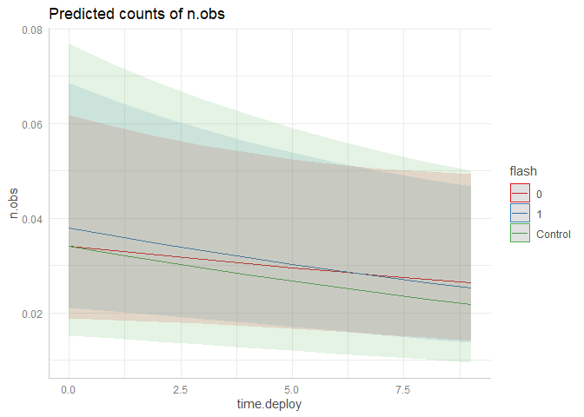

.5 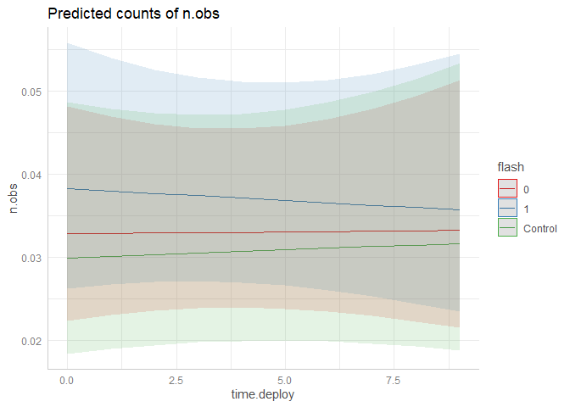

.5 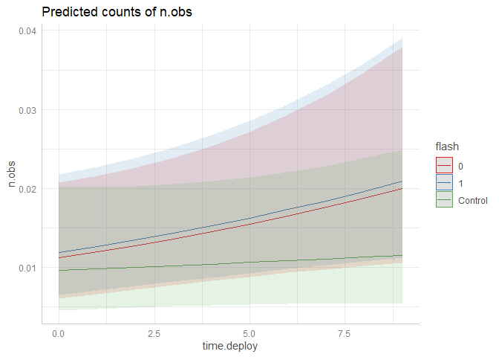

.5 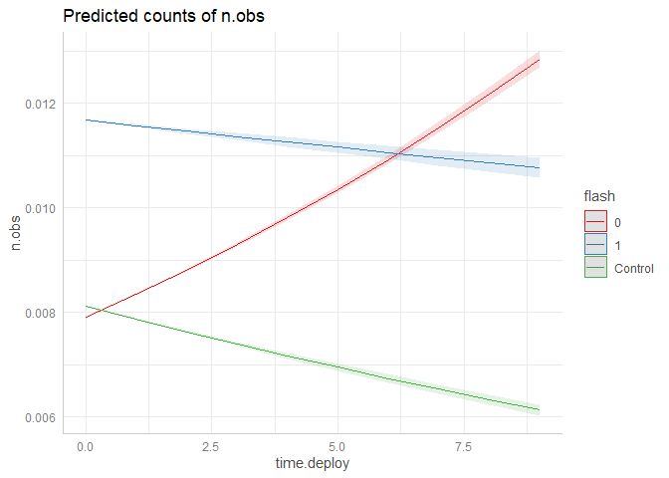

.5 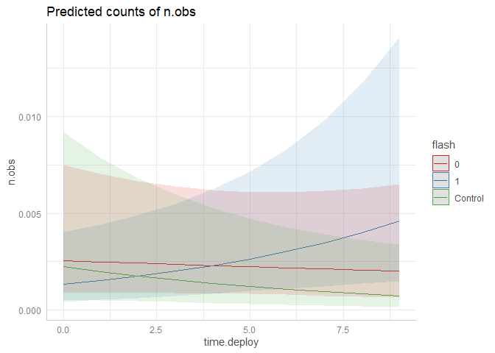

.5 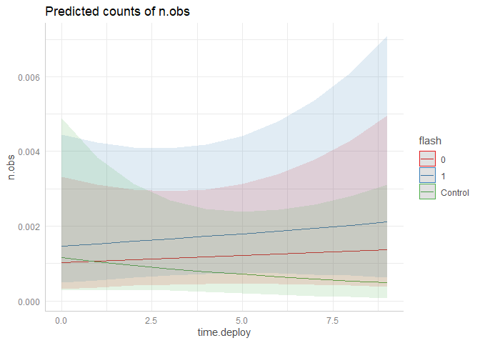

.4 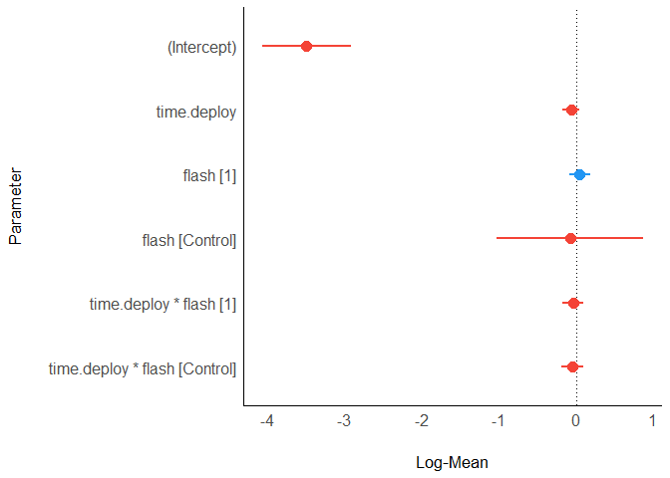

.4 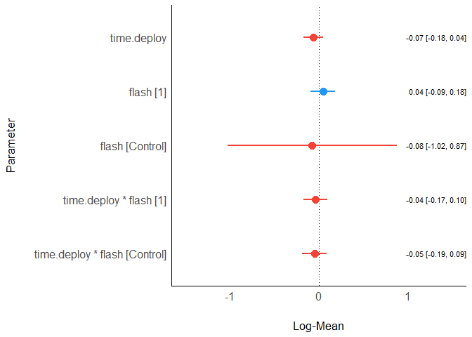

.8 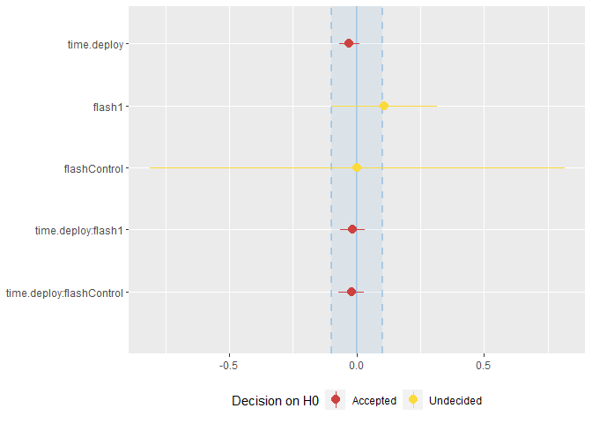

### Kommentar

Så langt har eg fokusert på rådyr, men nå er det ikkje så mykje arbeid å skrive vidare om resten av artene.

Planen er å lage eit felles plot i stil med eit av plottene i figur [fig:para_sp]. Då vil kvar art få kvart sitt konfidensintervall (CI) for kvar parameter. Dei to øverste er vanlige effect size-plot, det nederste er omformulert til ein ekvivalens-test som baserer seg på bayesisk statistikk, kor man kan akseptere nullhypoteser, ikkje berre avslå eller feile i å avslå.

Det er kanskje ikkje heilt naudsynleg å ta med, sidan eg ikkje har gjort bayesiske analyser, men den har blitt modifisert til frekventist-analyser også, og det er slik eg bruker den. Den oppfører seg som ein kommentar til / visualisering av p-testen. Vis parameter-effekten har heile CI sitt inni ROPE-området kan man “akseptere” nullhypotesen, uansett om p-verdien seier den er signifikant. Vis CI tangerer ROPE området kan man ikkje konkludere angåande parameteret. For meg resulterer begge disse tilfellene i at eg feiler med å avslå nullhypotesen.

Til slutt, vis CI er heilt utanfor ROPE-området, er effekten signifikant (p < 0.5) og eg kan avslå nullhypotesen.

Kva for ein variant av plottene synest du viser modellen best?

### CPH mixed effect

# Discussion

## GLMM

The intercept-value is considered significantly negative, which is to say that there were a low chance of detecting any roe deer at an IR-camera the same day I visited the camera (see figure [fig:para_raa1]).

This makes intuitive sence, as most large mammals would be scared away temporarily by a nearby human, especially the times i set up the additional camera boxes, which I did with an electrical drill.

Anecdotally, once I saw a roe deer about to walk by a CT when I came to inspect it. The roe deer saw me and fled, right before it was detected by the camera. I’ve also startled two badgers close by a CT. However, they didn’t run far away, and went on to repopulate the area quickly. Chances are I’ve scared animals other times as well, but haven’t noticed it.

The effect of time since deployment is non-significant, and $β=0.007$. That means there is no difference on the baseline detection rate for an IR camera over time (after controlling for seasonal changes).

For white LED flash $β=0.04$, meaning that the intercept is slightly higher than for IR, but the difference is non-significant.

The control-group has practically the same intercept as the IR-groups, and all of the groups is showing a negative trend, non-significant trend over time. The negative trends for the control- and IR-groups are strange, as they should represent a baseline detection probability, and any fluctuations in detection rates over the year should be controlled for by the weekly random effect-argument.

Seeing as all the parameters related to time since deployment are well within the ROPE area in figure (/ all have a non-significant p-value), it is safe to say that these “trends” are only due to chance.

The raw count-plots in Appendix A also shows that there are more outliers with extreme values (counts of up to 5 events per day) when time since deployment is close to 0, than towards the maximum lengths of periods. The largest counts stem from the control-group which in mainly has arbitrary days set as their day 0 in each period. Only a few cameras has a true visitation date as their day 0, which can be seen as their first point after a gap in figure [fig:timeseries_control].

Hypothesising:

**If $H_{1}$** is true, and there truly is an effect of the white LED for long periods on the detection rate of roe deer, this effect could in turn account for the different intercept values of IR and flash, as the IR periods usually starts after a flash period (with the exception of the first IR-period, i.e. first red periods in figure ).

Remembering my study design, 20 cameras start with white LED, 20 with IR. Intercept should theoretically be identical in the 1st period. 2nd period; white LEDs are moved. New LED CTs should have same intercept (unchanged detection rate), and new IR CTs should have a hypothetical lower intercept due to the effect of white LED. 3rd period; white LED moved, new LED CTs (IR intercept), new IR CTs (hypothetical lower intercept), and so on.

Which sums up to 3 IR periods where detection rates could start lower than that of white LED.

If that was true, and the white LED interacting with time had a significantly negative slope, then the slope of IR should be positive, as the roe deer detection rate returned to normal. The slope for the control-group(time.deploy:flashControl) should represent a normal detection rate, and be close to flat ($β≈0$), intercept possibly closer to that of white LED, than IR.

## Kommentar

Om “Hypothesising”-delen skal med på noko vis må den heilt klart skrivast om, men eg inkluderte den foreløpig for å høyre om du synst den har ein plass i diskusjons-delen ein eller annan plass.

I tillegg er mesteparten av skrift her truleg overflødig, men eg skreiv den simultant med modelleringa for at eg skulle forstå meg sjølv igjen etter at det hadde gått nokon dager. Kor utdypande er det verdt å gå i detaljnivået her? Burde eg droppe å utdype ting som likevel ikkje er signifikant?